Assignment 1
Functional Programming
Kaloyan Stoykov and Dimitar Byalkov
Caesar Cypher and Pythagoras 1

Here we have provided some screenshots with text explanation of what we have done and what the code actually does.

N.B. – WE actually have made some decisions about the implementation of the solution but we want to check with the feedback first before going all-in

Caesar Cypher
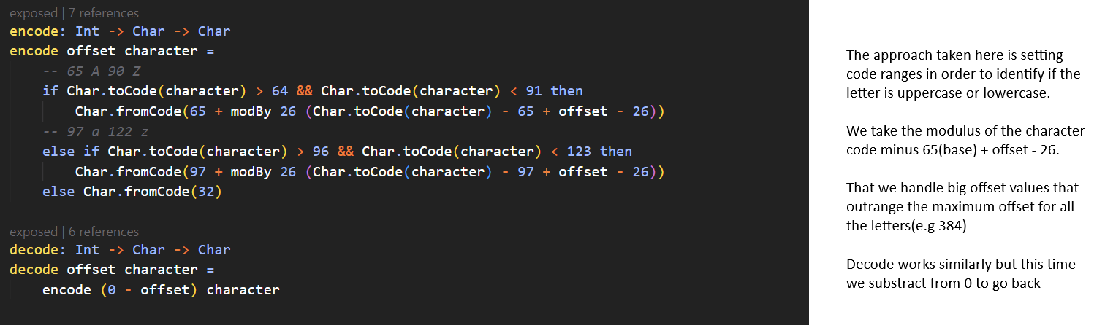

Pythagoras’ Theorem
